The Conspirators is the second in The Race Bannon Adventures and picks up immediately after the events of The Synthetic Men. The stakes are even higher as Race and Team Quest encounter the ghostly Phantom Cosmonaut. Cut off by Intelligence 1, they turn to old allies as they seek out the conspirators behind the origin of the deadly Synthetics.
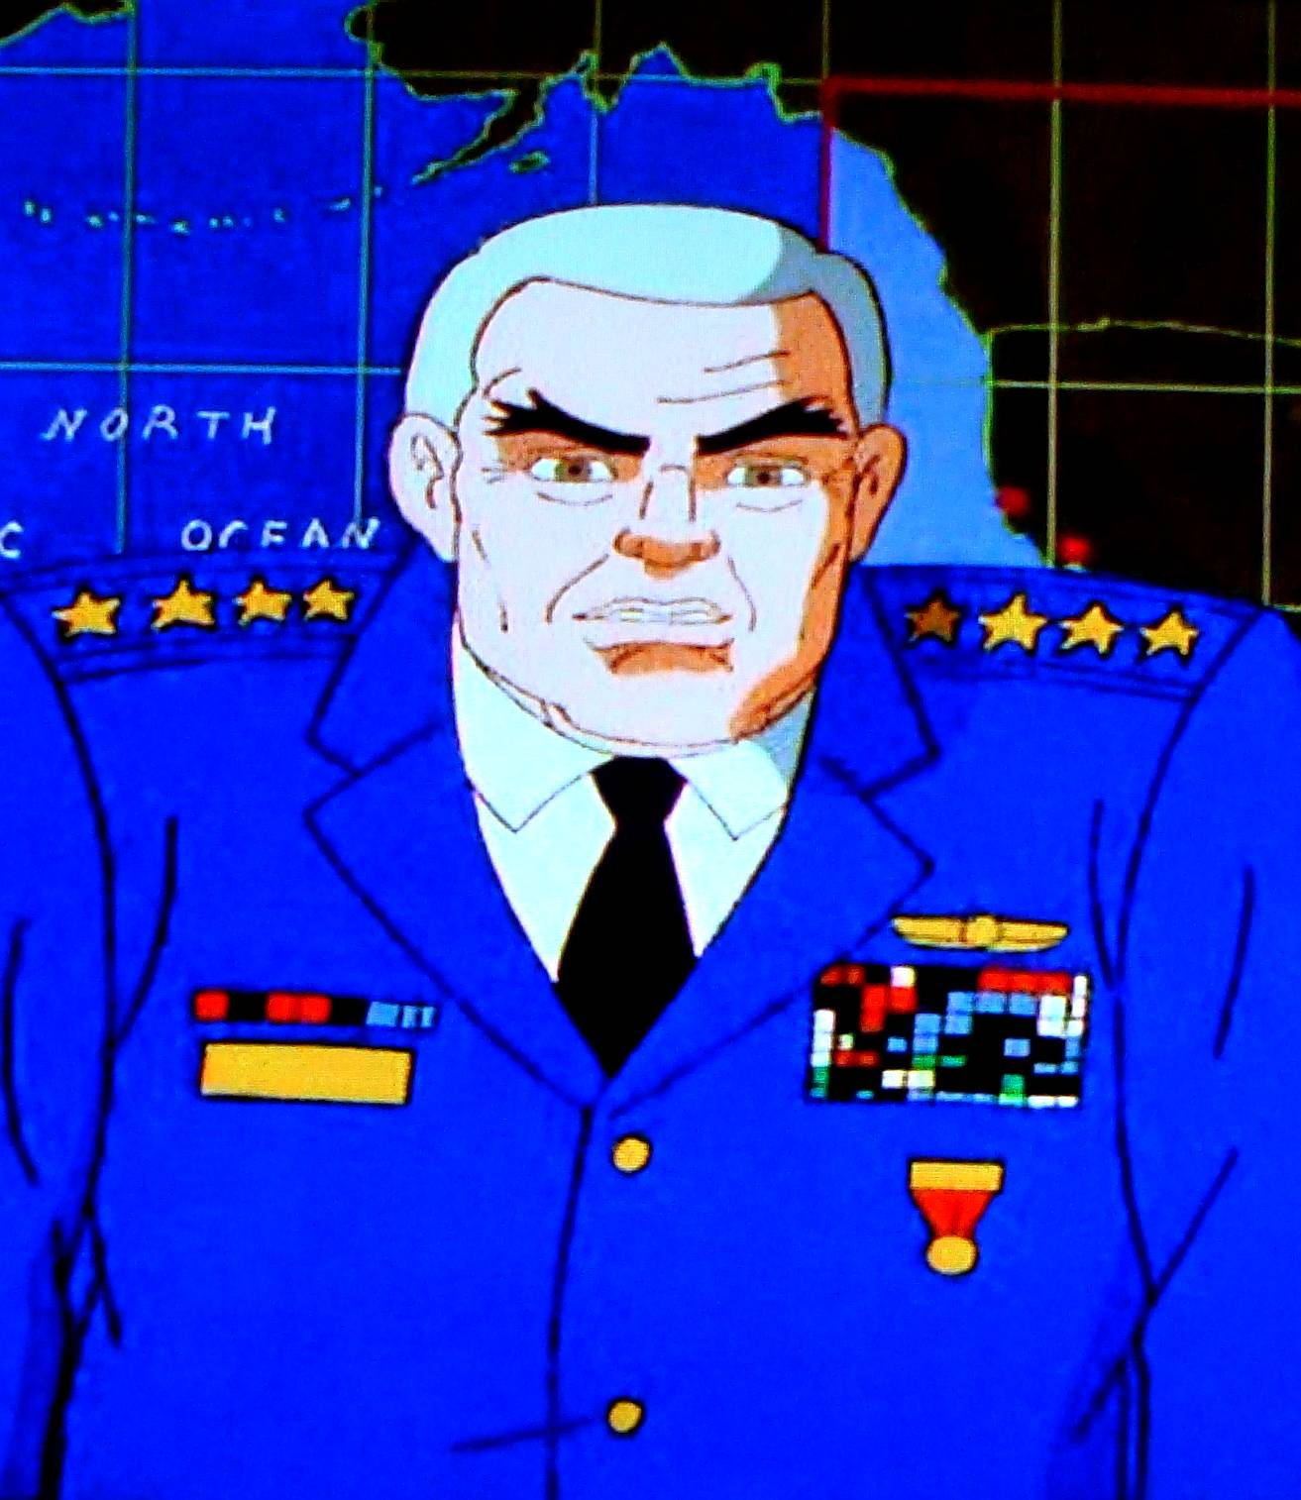

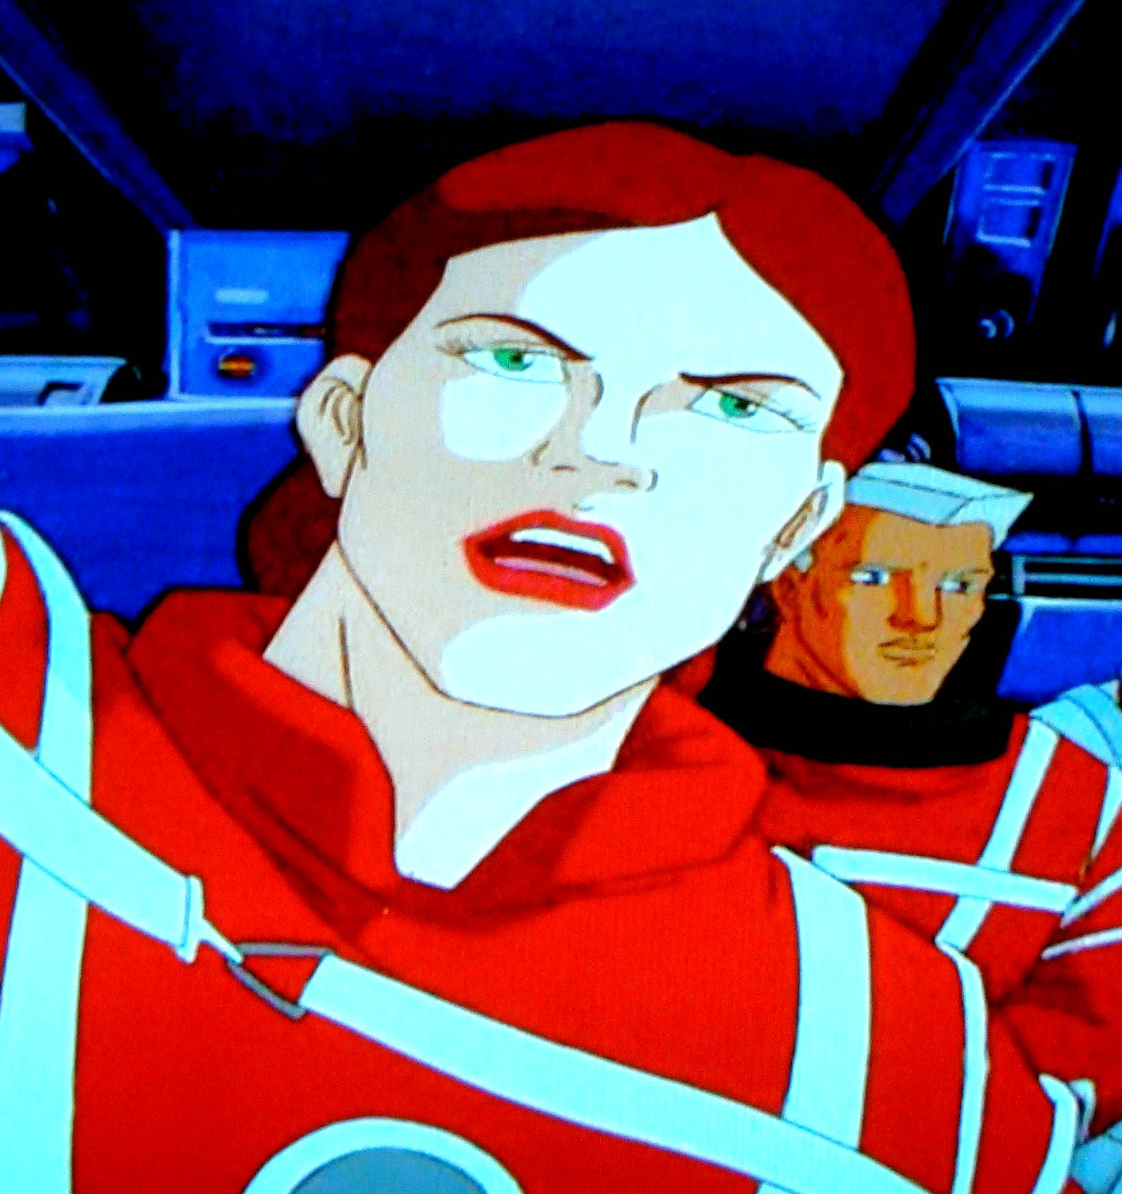
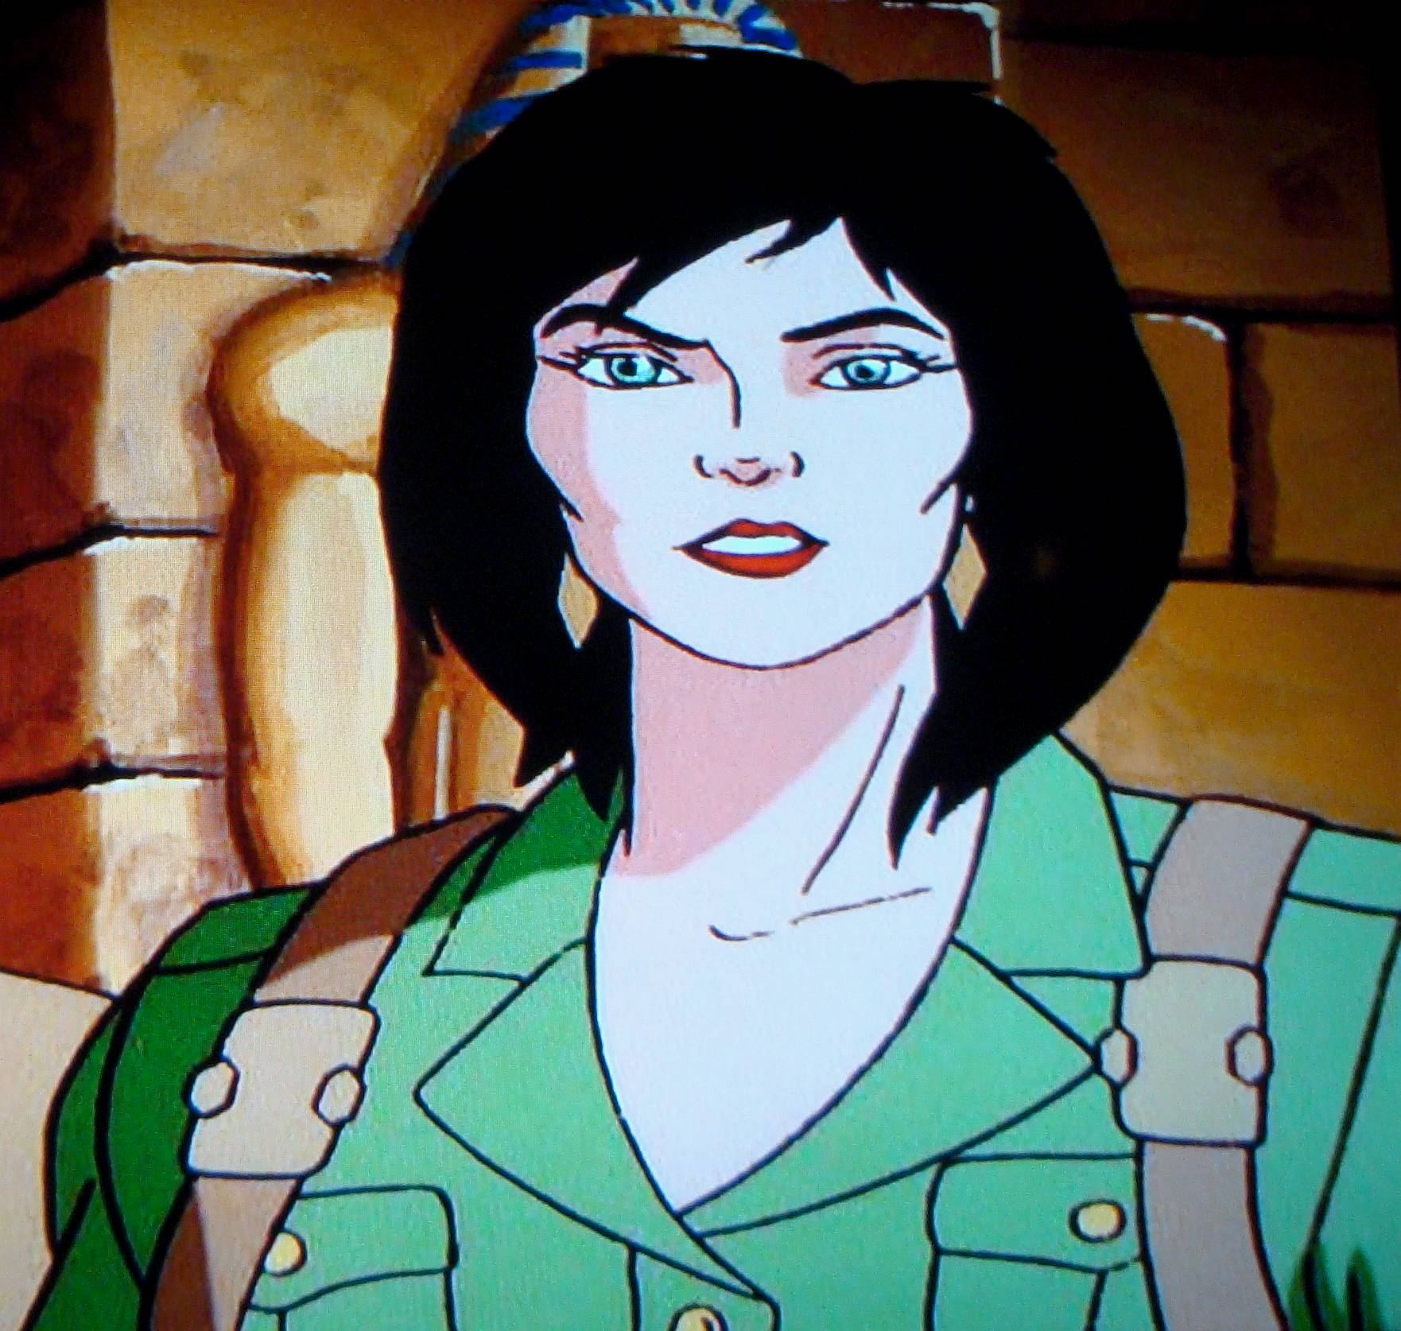
Familiar characters and story references from the Quest franchise abound. Gen. Tyler from the New Adventures episode Alien in Washington and the Cover-up at Roswell JQ computer game plays a major role, as does New Adventures regular Cmdr. Bennett. Cosmonaut Natasha Rostova, from Rage's Burning Wheel also makes an appearance along with recurring arch-villain Gen. Vostok. Events from the second season New Adventures episodes DNA Doomsday and Nemesis feature prominently in the backstory. Best of all, JQ franchise mainstay and Race Bannon flame Jezebel Jade Kenyon joins Team Quest on their latest adventure.
Various JQ entities and items of Quest tech also make an appearance. SRX Research and the Vanguard Space Cruiser are taken from the Eighties Adventures episode Aliens Among Us. The Q-Sphere was featured in Tom and Jerry's Spy Quest. My description of Dr. Quest's laboratory is also a nod to Spy Quest. The Synapse Imager appeared in Jonny's Golden Quest and reappeared as the VR Memory Probe in the Real Adventures episode Bloodlines.

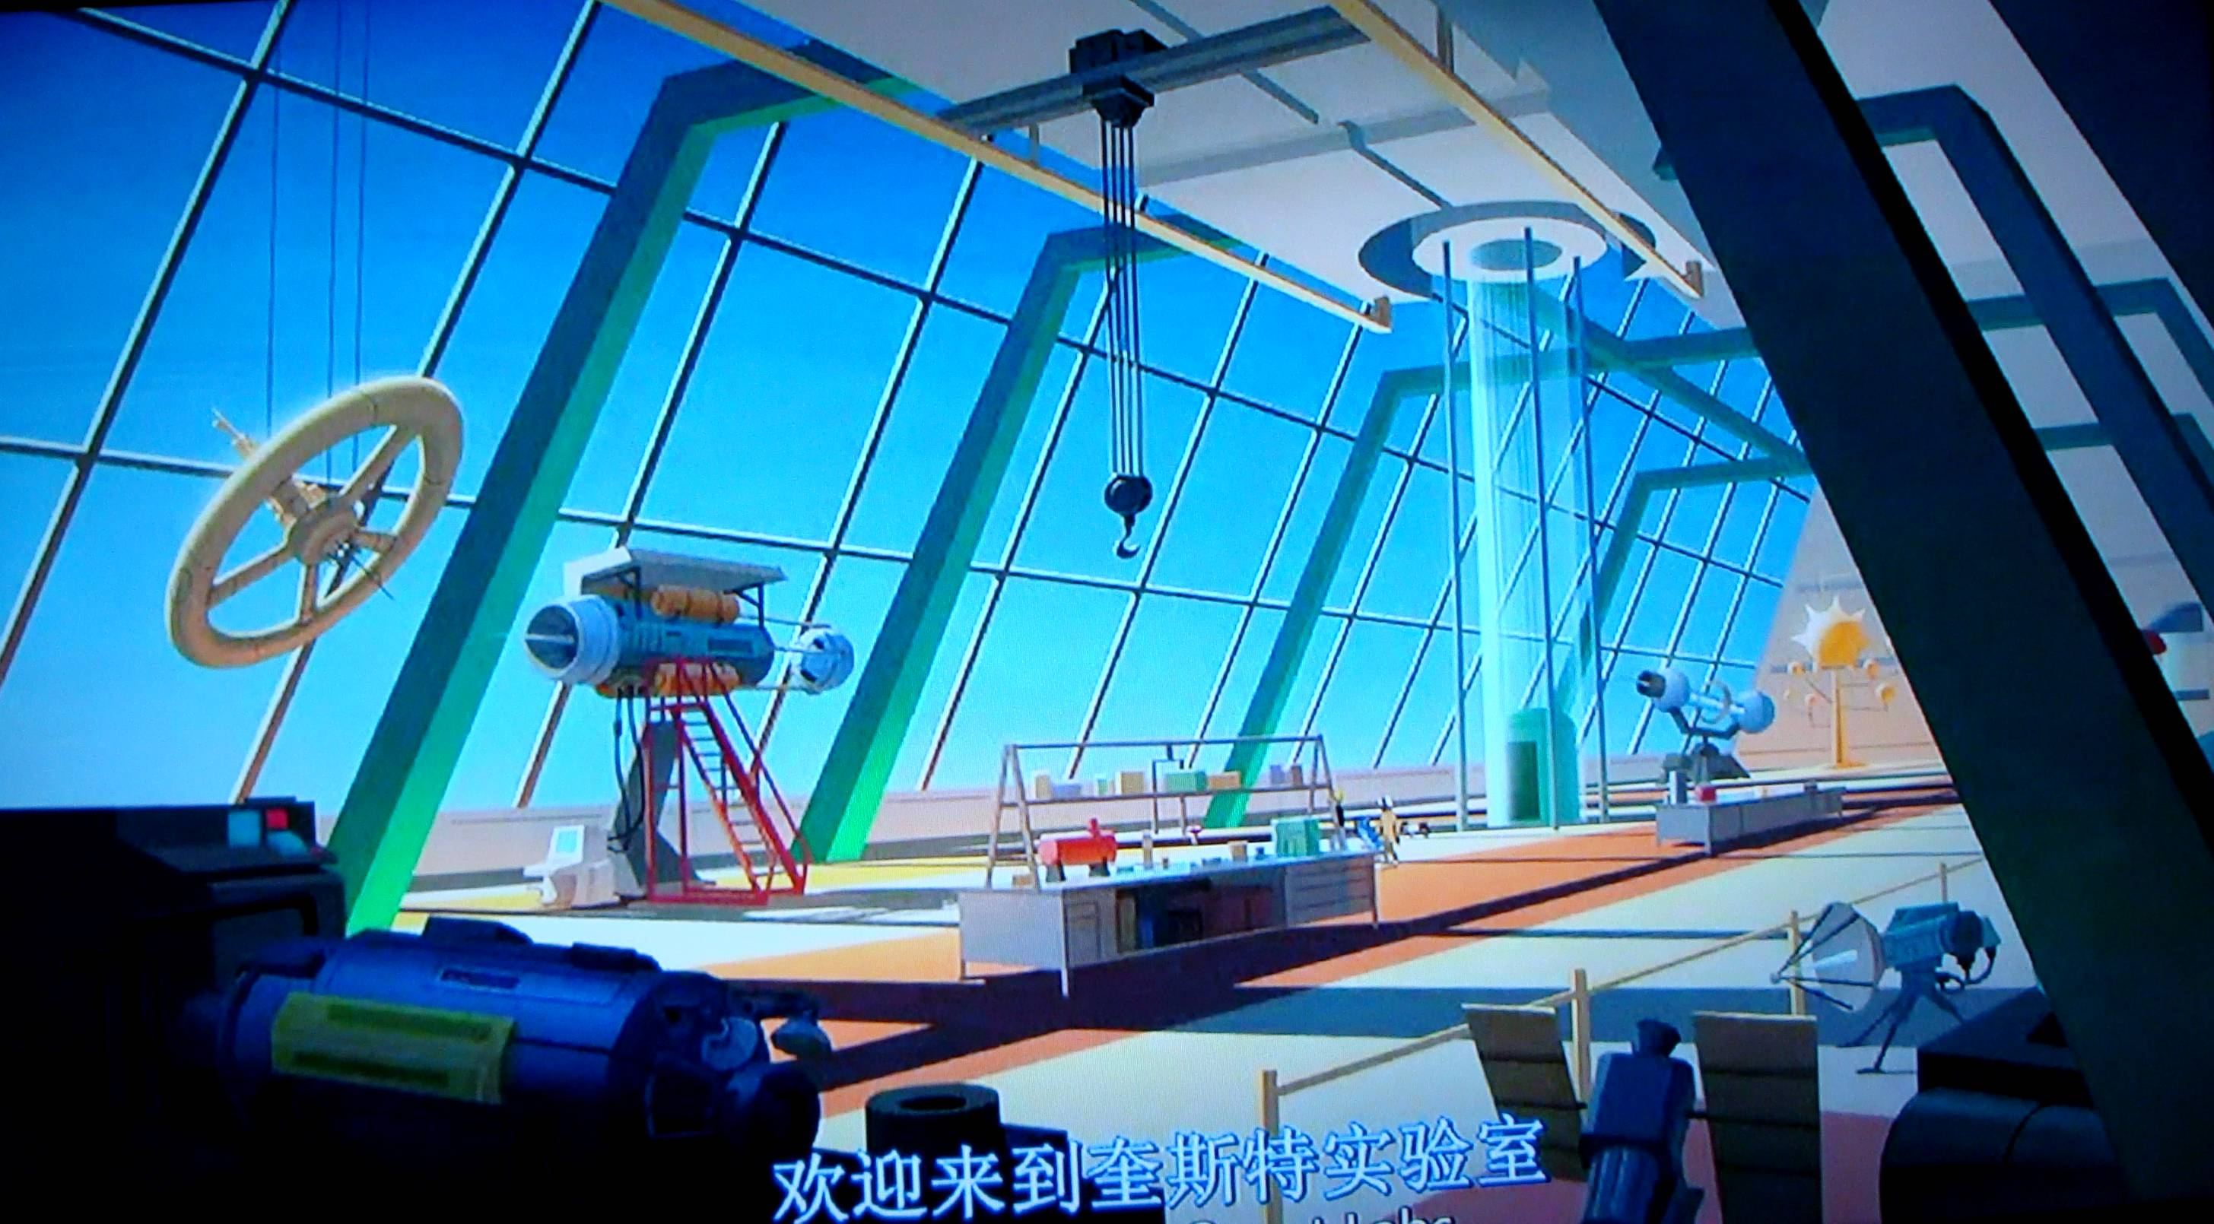

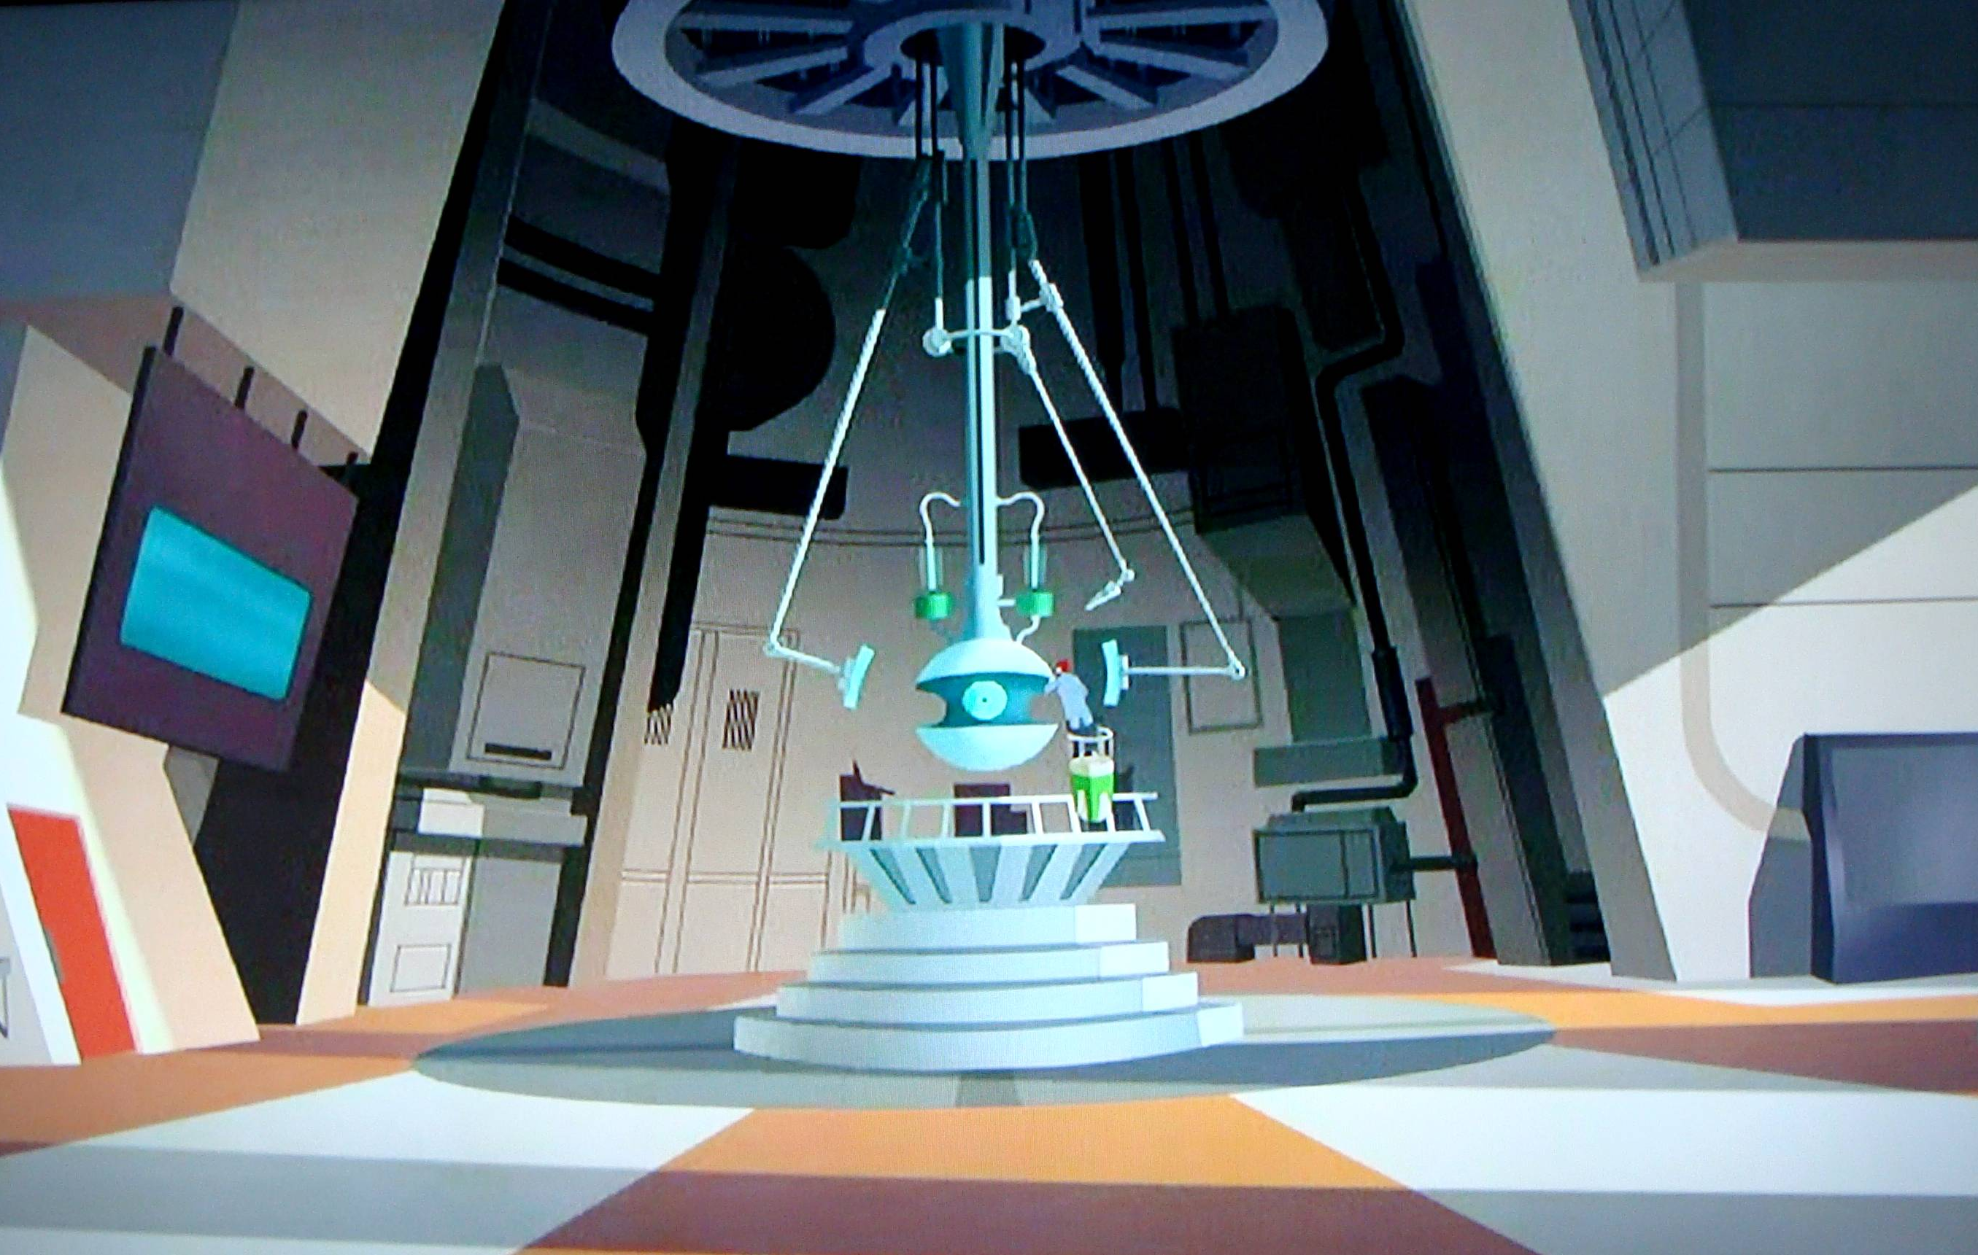
The Conspirators contains fictionalized versions of some real world organizations as well. The real Air Force Space Command is based at Peterson AFB in Colorado Springs and the Office of the Director of National Intelligence (ODNI) does oversee the US Intelligence Community. My descriptions of the SRX-33 and the SRX Vanguard Space Cruiser are loosely based on the prototype X-33 and the proposed VentureStar spaceplane as well as the secretive missions of the X-37 Orbital Test Vehicle.
I hope Jonny Quest fans will continue to enjoy The Race Bannon Adventures fan fiction. Reader comments are welcome. Please send to RichardScarpitti@hotmail.com.

