The Synthetic Men is a Jonny Quest fan fiction inspired by the animated programs created by Hanna Barbera. Born in 1956, I recall watching the original airings of Classic Jonny Quest when I was in the third grade. A lifelong science fiction fan, a few years ago I got into a nostalgia phase and ordered the JQ Classic DVD set. From there I went on to the made-for-TV movies, the Eighties Adventures, and then everything else JQ. Starting to think about what a modern take on Jonny Quest would look like, I began to jot down ideas for story hooks, exotic locales, and JQ-type real world tech. June of 2018, I took the plunge and started in on my first JQ short novella.
The Synthetic Men is essentially a follow-up to the original Jonny Quest series. It takes place in the present day, approximately 12 years after the events of Classic JQ. The story is told from the viewpoint of Race Bannon and incorporates the original JQ cast of main characters. Prof. Eriksson and Gunnar from the House of Seven Gargoyles episode also put in an appearance along with Race's handler, Corvin. Most importantly, I have strived for the atmosphere of genuine menace by sinister forces that was only present in the original series.
While later programs in the franchise do not totally fit into a consistent canon with Classic JQ, I have selectively picked out various character references and Easter eggs from them. Astute JQ fans will recognize Cmdr. Harris from JQ vs. the Cyber Insects and Judd Harmon, a.k.a. Skyborg from the Eighties Adventures. Hadji's return to Bangalore comes from the Real Adventures continuity. Main cast additions Jessie Bannon and Hardrock have not been included.
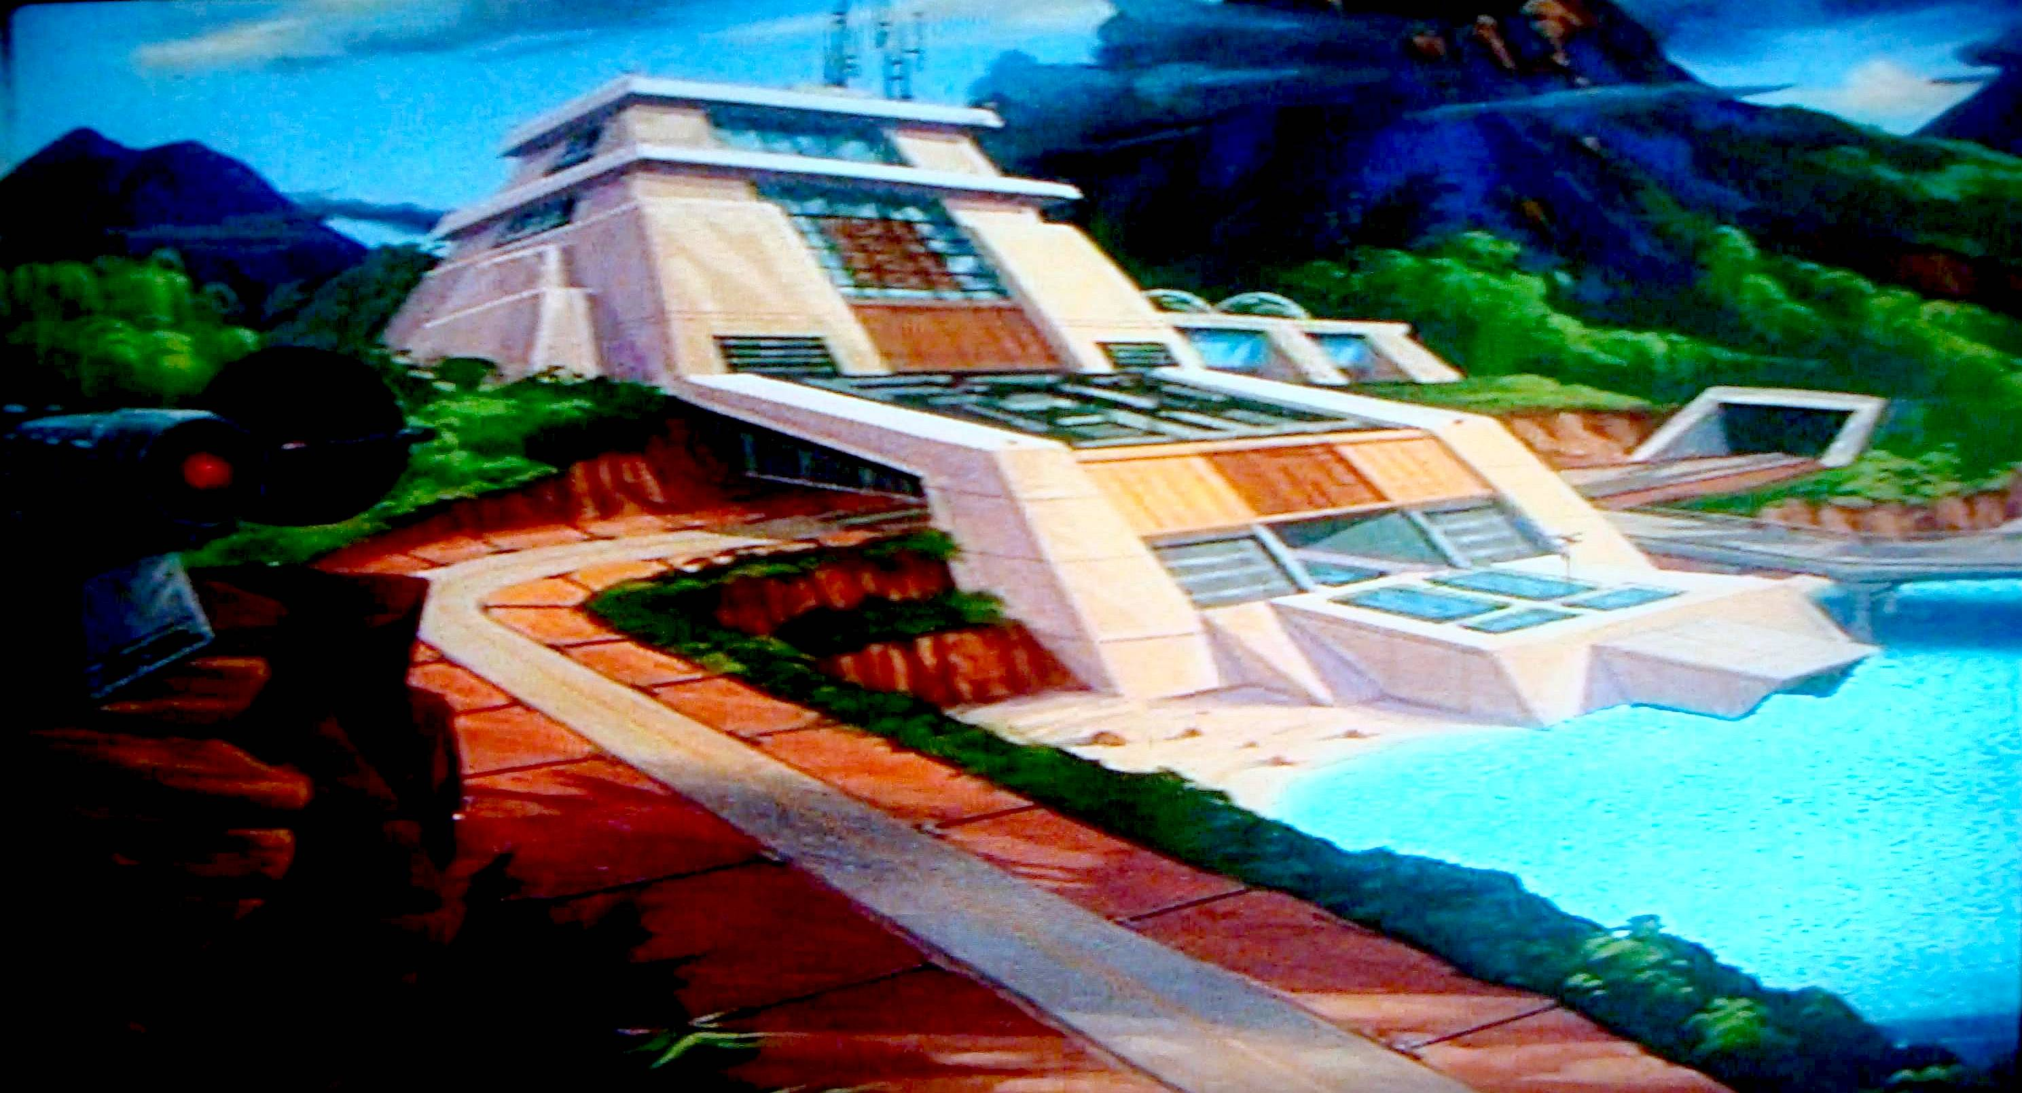
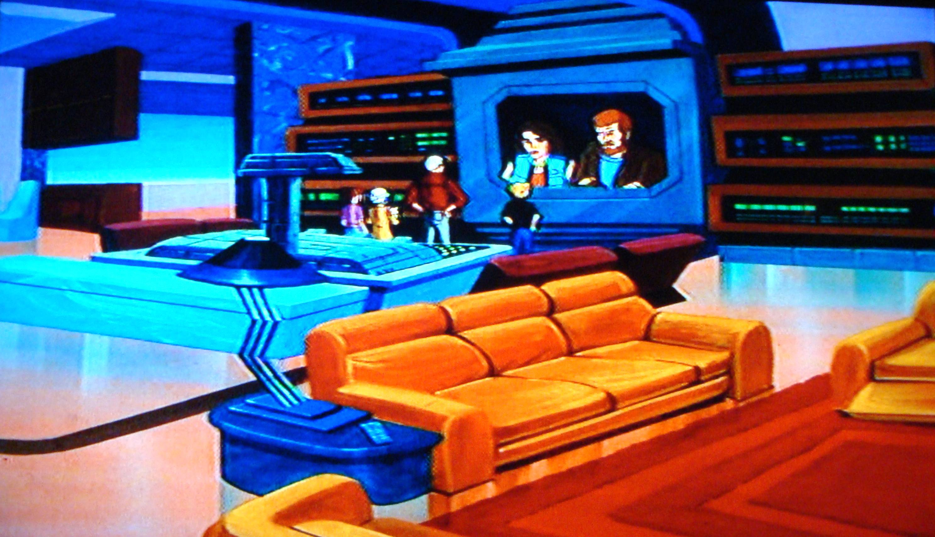
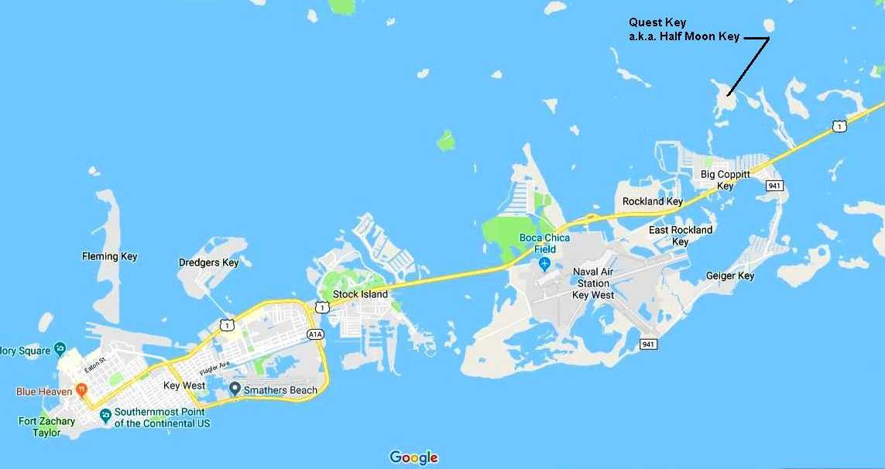
The description of the current Quest Headquarters comes from Jonny's Golden Quest, however I transposed the location from Mexico to Quest Key, a reference from Tom and Jerry's Spy Quest. Maintaining the security of the Quests and their inventions from hostile forces is an established premise of the series. With this in mind, I placed my Quest Key just North of the real world Naval Air Station Key West on Boca Chica Key. If you look on Google Maps, in reality, this location is occupied by the uninhabited Half Moon Key. Presumably if the Quests were to acquire this location, they could rename it.
The real world Cerro Paranal facility of the European Southern Observatory makes for an incredible Jonny Quest location. This amazing organization, besides being at the forefront of astronomical and cosmological research, does an awesome job of public outreach. Their detailed website and fascinating ESOcast YouTube videos were a tremendous reference in writing The Synthetic Men. Any fan of the science-based animated adventures of Jonny Quest should be mesmerized by this real world counterpart to the Quest Institute. Aside from being a little melodramatic with my descriptions of the LGSF and the VLT mirror carriage, hopefully I've presented the operations of Cerro Paranal in a realistic and positive light.
The Classic Jonny Quest website has been a source of both information and inspiration in writing The Synthetic Men. I'm thrilled at the opportunity to contribute to this site. Hopefully this story will allow fans to recapture some of the magic and the goosebumps of watching this amazing television series.

